1. Create a table called Playlist with columns: song_id (integer), song_name (varchar), artist (varchar), and set song_id as the PRIMARY KEY.
Ans:
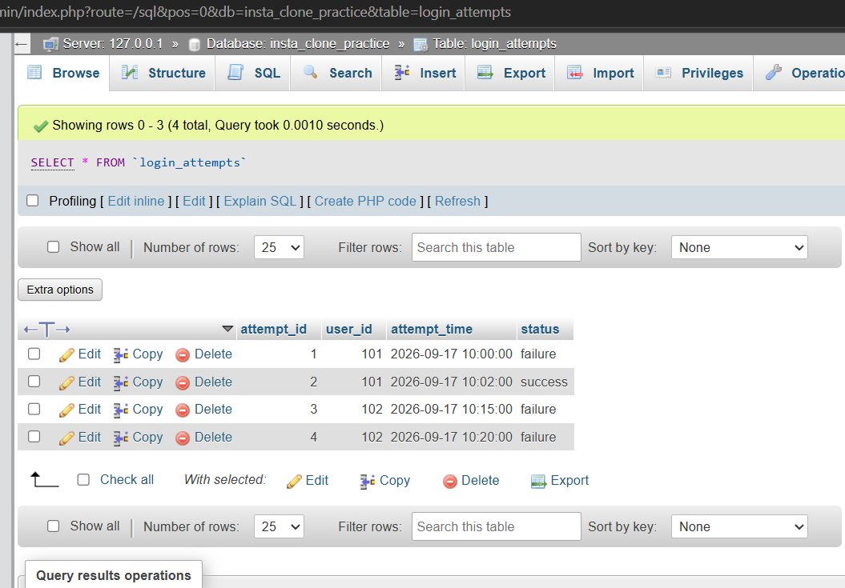

2. Create a table called UserProfile with columns: user_id (integer, PRIMARY KEY), username (varchar, UNIQUE), email (varchar, NOT NULL), and city (varchar, DEFAULT 'Ahmedabad').
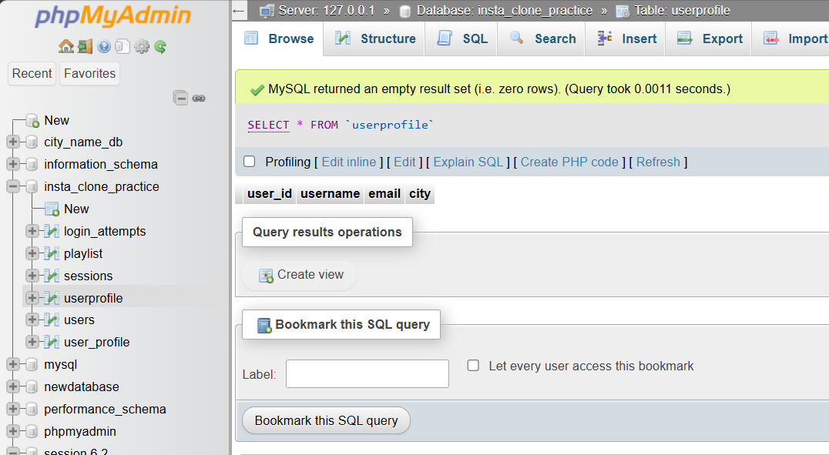

3. Create a table called Follows to represent Instagram-style followers with columns: follower_id (integer), followed_id (integer), and set both as FOREIGN KEYs referencing user_id in UserProfile.
Ans:
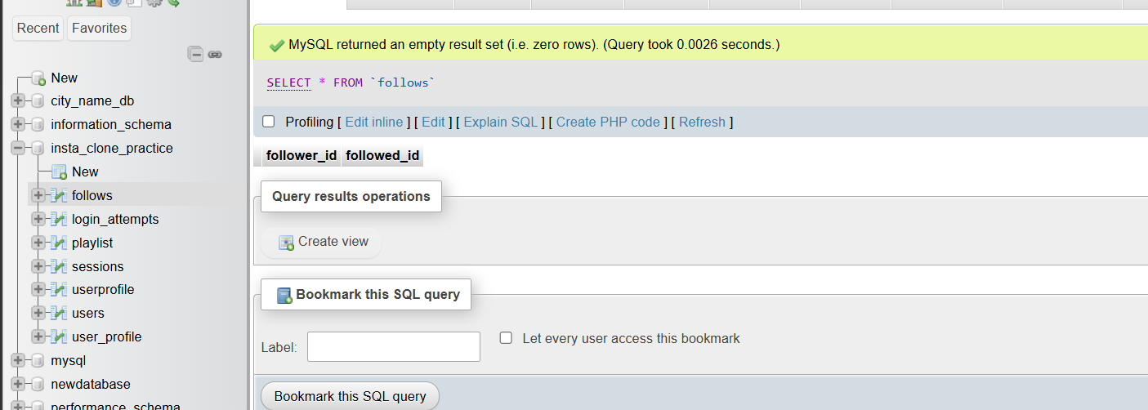

4. Try to insert a new UserProfile row with a NULL value for email and observe the error message generated by the NOT NULL constraint.<br><br><em><strong>Hint:</strong> Note the exact error text returned by your database system.</em>
Ans:
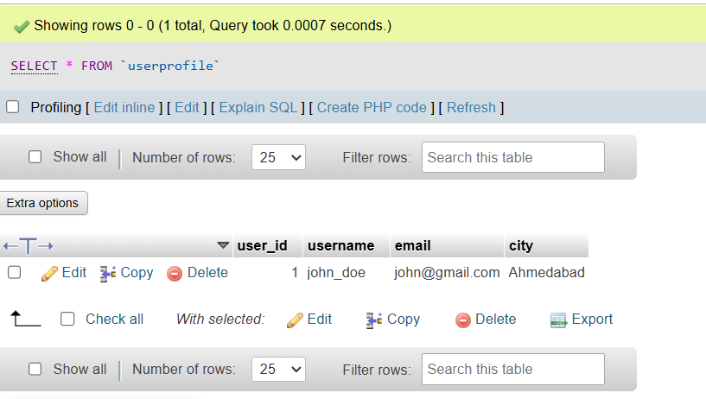

5. Add a CHECK constraint to the Playlist table so that song_name must be at least 3 characters long, then attempt to insert a song with a 2-character name and record the error message.
Ans: 